**Data Cleaning**

/** Script to remove subsector industry codes, keeping only major sector codes **/

SELECT [NAICS_Codes]

,[NAICS_Industry_Description]

FROM [SBA].[dbo].[sba_industry_standards]

WHERE NAICS_Codes = ''

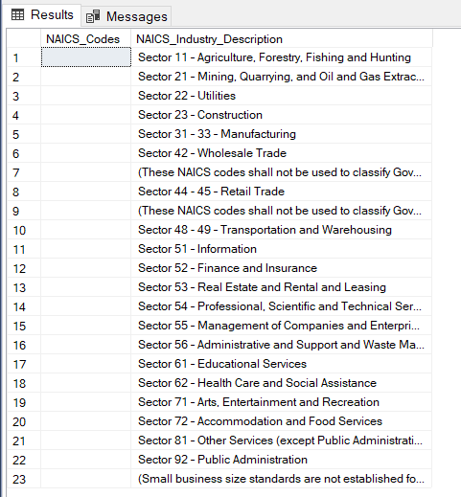

/****** Script to delete the NAICs code column ******/

SELECT

[NAICS_Industry_Description] AS Industry_Sector

FROM [SBA].[dbo].[sba_industry_standards]

WHERE NAICS_Codes = ''

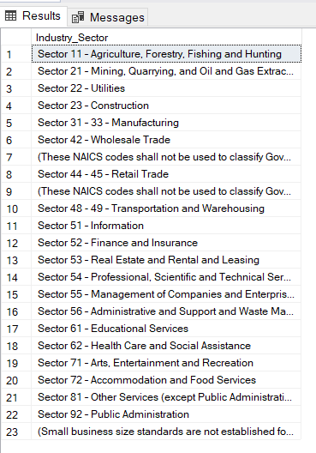

/** Script to extract industry codes using SQL substring function and add them to a new column **/

SELECT

[NAICS_Industry_Description] AS Industry_Sector,

CASE WHEN NAICS_Industry_Description LIKE '%–%' THEN SUBSTRING(NAICS_Industry_Description, 8, 2) END AS Sector_codes

FROM [SBA].[dbo].[sba_industry_standards]

WHERE NAICS_Codes = ''

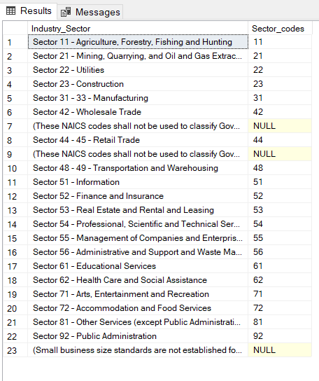

/****** Subquery to drop all NUL values ******/

SELECT *

FROM (

SELECT

[NAICS_Industry_Description] AS Industry_Sector,

CASE WHEN NAICS_Industry_Description LIKE '%–%' THEN SUBSTRING(NAICS_Industry_Description, 8, 2) END AS Sector_codes

FROM [SBA].[dbo].[sba_industry_standards]

WHERE NAICS_Codes = ''

) MAIN

WHERE Sector_Codes != ''

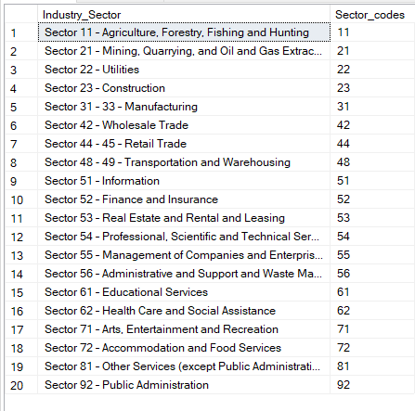

/****** Script to extract the Industry Sector Name******/

SELECT *

FROM (

SELECT

[NAICS_Industry_Description] AS Industry_Sector,

CASE WHEN NAICS_Industry_Description LIKE '%–%' THEN SUBSTRING(NAICS_Industry_Description, 8, 2) END AS Sector_codes,

CASE WHEN NAICS_Industry_Description LIKE '%–%' THEN ltrim(SUBSTRING(NAICS_Industry_Description, CHARINDEX('–', NAICS_Industry_Description) + 1, LEN(NAICS_Industry_Description))) END AS Industry_SectorName

FROM [SBA].[dbo].[sba_industry_standards]

WHERE NAICS_Codes = ''

) MAIN

WHERE Sector_Codes != ''

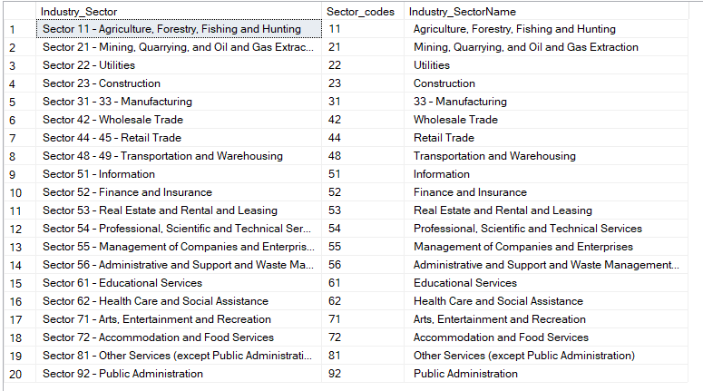

/** Script to save INTO a new table **/

SELECT *

INTO SBA_Sector_Codes_Descriptions2

FROM (

SELECT

[NAICS_Industry_Description] AS Industry_Sector,

CASE WHEN NAICS_Industry_Description LIKE '%–%' THEN SUBSTRING(NAICS_Industry_Description, 8, 2) END AS Sector_codes,

CASE WHEN NAICS_Industry_Description LIKE '%–%' THEN ltrim(SUBSTRING(NAICS_Industry_Description, CHARINDEX('–', NAICS_Industry_Description) + 1, LEN(NAICS_Industry_Description))) END AS Industry_SectorName

FROM [SBA].[dbo].[sba_industry_standards]

WHERE NAICS_Codes = ''

/****** Script to edit and update the table using Insert INTO ******/

Select

Industry_Sector,

Sector_codes,

Industry_SectorName

from SBA_Sector_Codes_Descriptions

insert into SBA_Sector_Codes_Descriptions

values

('Sector 31 - 33 - Manufacturing', 32, 'Manufacturing'),

('Sector 31 - 33 - Manufacturing', 33, 'Manufacturing'),

('Sector 44 - 45 - Retail Trade', 44, 'Retail Trade'),

('Sector 48 - 49 - Transportation and Warehousing, 48, 'Transportation and Warehousing'),

('Sector 48 - 49 - Transportation and Warehousing, 49, 'Transportation and Warehousing')

Select

Industry_Sector,

Sector_codes,

update SBA_Sector_Codes_Descriptions2

set Industry_SectorName = 'Manufacturing'

where Sector_codes = 31

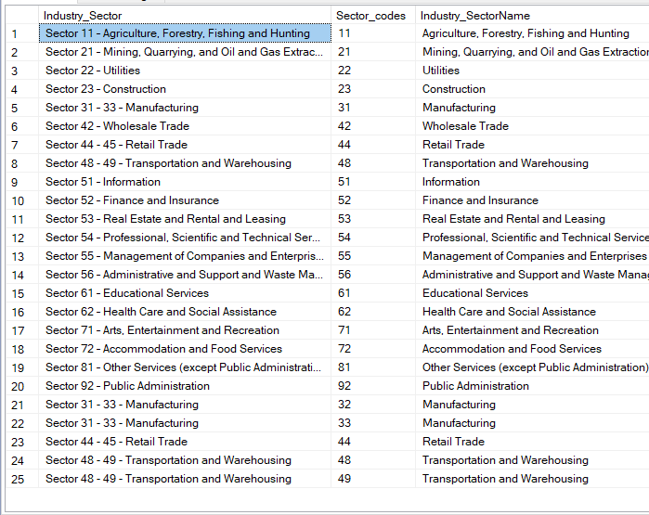

**Exploration and Analysis**

---What is the summary of all the approved PPP loans---

/****** What are the KPI values for the approved PPP loans? ******/

SELECT

COUNT(LoanNumber) AS Total_Approved_Loans,

SUM(InitialApprovalAmount) AS Total_Approved_amount,

AVG(InitialApprovalAmount) AS Average_Loan_Size,

SUM(PAYROLL_PROCEED) AS Reported_As_Payroll_Proceeds

FROM [SBA].[dbo].[SBA_Public_Data]

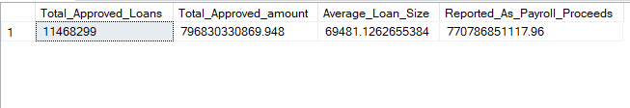

/****** What percentage of PPP loans were forgiven? ******/

SELECT

COUNT(LoanNumber) AS Total_Approved_Loans,

SUM(InitialApprovalAmount) AS Total_Approved_amount,

SUM(ForgivenessAmount) AS Amount_Forgiven,

ROUND(SUM(ForgivenessAmount)/SUM(InitialApprovalAmount) * 100, 2)As Percentage_Forgiven

FROM

[SBA].[dbo].[SBA_Public_Data]

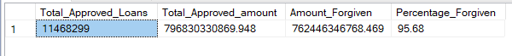

/****** KPI’s Grouped by Year ******/

SELECT

YEAR(DateApproved),

COUNT(LoanNumber) AS Total_Approved_Loans,

SUM(InitialApprovalAmount) AS Total_Approved_amount,

AVG(InitialApprovalAmount) AS Average_Loan_Size,

SUM(PAYROLL_PROCEED) AS Reported_As_Payroll_Proceeds

FROM

[SBA].[dbo].[SBA_Public_Data]

WHERE

YEAR(DateApproved) = 2020

GROUP BY

YEAR(DateApproved)

UNION

SELECT

YEAR(DateApproved),

COUNT(LoanNumber) AS Total_Approved_Loans,

SUM(InitialApprovalAmount) AS Total_Approved_amount,

AVG(InitialApprovalAmount) AS Average_Loan_Size,

SUM(PAYROLL_PROCEED) AS Reported_As_Payroll_Proceeds

FROM

[SBA].[dbo].[SBA_Public_Data]

WHERE

YEAR(DateApproved) = 2021

GROUP BY

YEAR(DateApproved)



/** Which are the top 15 lending institutions that provided the majority of PPP loans?

SELECT TOP 15

OriginatingLender,

COUNT(LoanNumber) AS Total_Approved_Loans,

SUM(InitialApprovalAmount) AS Total_Approved_amount,

AVG(InitialApprovalAmount) AS Average_Loan_Size,

SUM(PAYROLL_PROCEED) AS Reported_As_Payroll_Proceeds

FROM

[SBA].[dbo].[SBA_Public_Data]

GROUP BY

OriginatingLender

ORDER BY 3 DESC

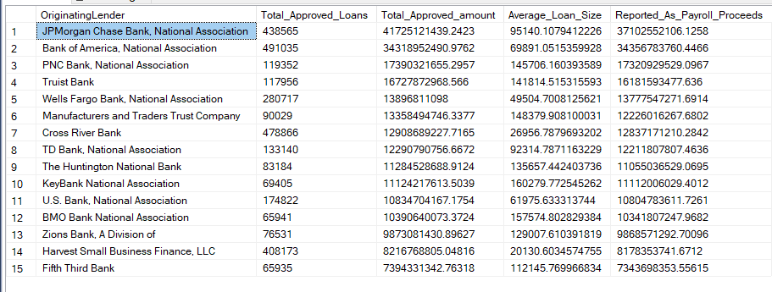

/****** Which are the top 15 Sectors that received the majority of PPP loans? ******/

SELECT TOP 15

sc.Industry_SectorName,

COUNT(LoanNumber) AS Total_Approved_Loans,

SUM(InitialApprovalAmount) AS Total_Approved_amount,

AVG(InitialApprovalAmount) AS Average_Loan_Size,

SUM(PAYROLL_PROCEED) AS Reported_As_Payroll_Proceeds

FROM

[SBA].[dbo].[SBA_Public_Data] pd

join SBA_Sector_Codes_Descriptions2 sc

ON left(pd.NAICSCode, 2) = sc.Sector_codes

GROUP BY

sc.Industry_SectorName

ORDER BY 3 DESC

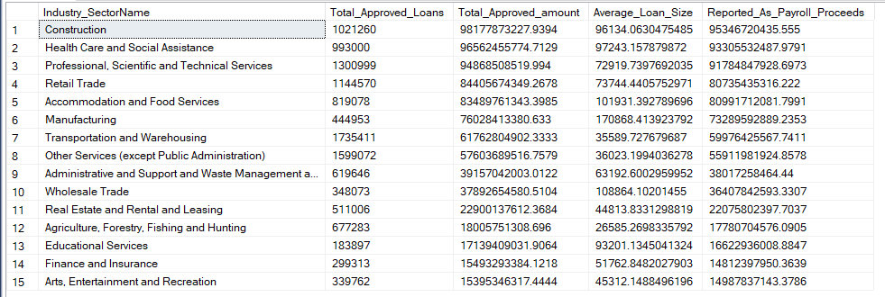

/**What is the % of approved loans by the top 15 Industry Sectors, using CTE’s **/

; with CTE AS

(

SELECT TOP 15

sc.Industry_SectorName,

COUNT(LoanNumber) AS Total_Approved_Loans,

SUM(InitialApprovalAmount) AS Total_Approved_amount,

AVG(InitialApprovalAmount) AS Average_Loan_Size,

SUM(PAYROLL_PROCEED) AS Reported_As_Payroll_Proceeds

FROM

[SBA].[dbo].[SBA_Public_Data] pd

join SBA_Sector_Codes_Descriptions2 sc

ON left(pd.NAICSCode, 2) = sc.Sector_codes

GROUP BY

sc.Industry_SectorName

--ORDER BY 3 DESC

)

SELECT Industry_SectorName, Total_Approved_Loans, Total_Approved_amount,

ROUND(Total_Approved_amount/SUM(Total_Approved_amount) OVER() * 100, 2) AS Percentage_Of_Total_Approved_Amount

from CTE

ORDER BY Total_Approved_amount desc

